LAB 7 (HW)
- Create a class `Calculator` that demonstrates method overloading by performing operations on different data types (`int`, `float`, `double`) and varying number of parameters.
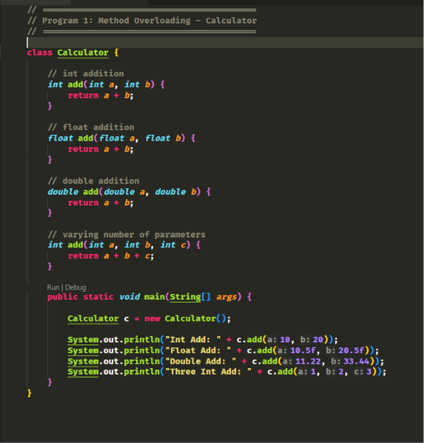
OUTPUT 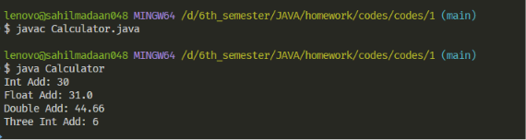

LAB 7 (HW)
- Develop a program where a superclass defines a generic method (e.g., `displayDetails()`), and subclasses provide specialized implementations
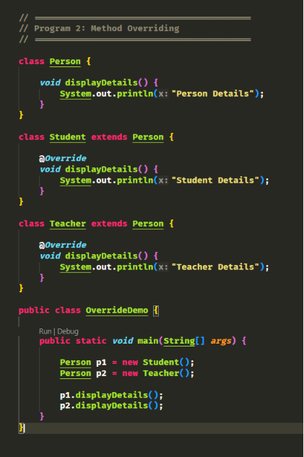
OUTPUT:
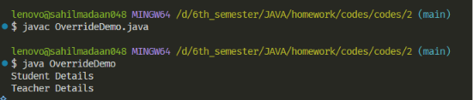

LAB 7 (HW)
- Write a program to demonstrate that method overriding requires the same method signature and analyze cases where it fails due to modified parameters.
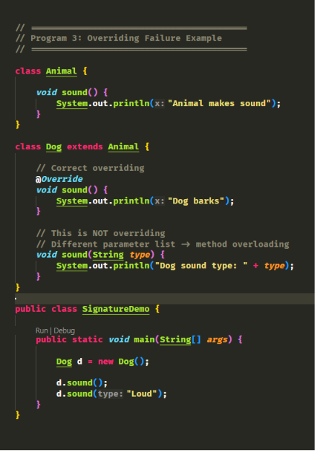

OUTPUT:
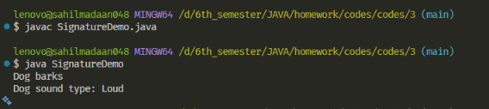

LAB 7 (HW)
- Write a program to demonstrate method overriding with covariant return types (child class returning a more specific type than parent).
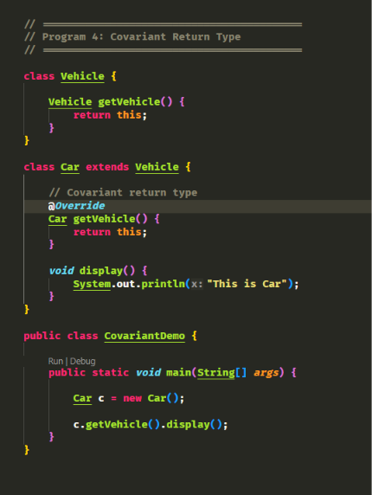
OUTPUT:
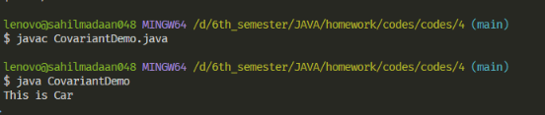
LAB 7 (HW)
- Develop a program to show that private methods cannot be overridden and analyze the behavior.
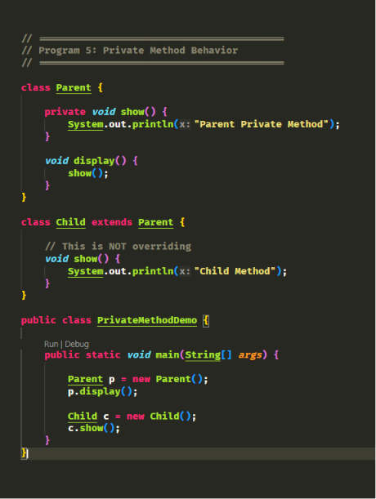
OUTPUT:
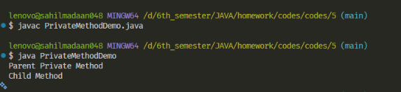
LAB 7 (HW)
6. Create a program to demonstrate overriding rules related to:
* Access modifiers (increasing visibility)
* Changing the return types
* Parameter consistency
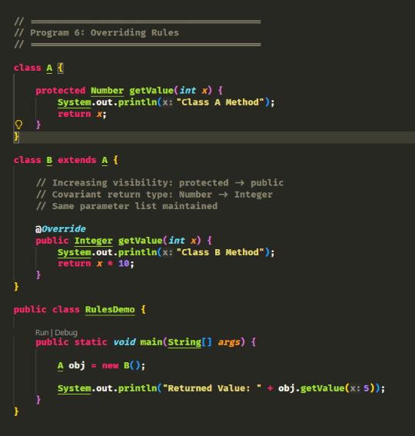
OUTPUT:
